Supporting Information
ROS-triggered self-accelerating drug release nanosystem with charge conversion for enhanced cancer therapy
Xinyi Zhang¹, Tiantian Zhu², Yaxin Miao³, Lu Zhou³, Weifang Zhang¹*.
1.Department of Pharmacy/Respiratory Diseases, The Second Affiliated Hospital of Nanchang University, Nanchang 330006, China.
2.Teaching and Research Office of Clinical Pharmacology, College of Pharmacy, Xinxiang Medical University, Xinxiang, 453003, China.
3.Medical College of Nanchang University，Nanchang, 330031，China.
*Corresponding to Weifang Zhang, e-mail: zhaweifang@163.com, Tel.: +86-0791-86303184.
Fig.S1 ¹H-NMR spectra of PEG-b-PLL(Z) and PEG-b-PLL.
PEG-b-PLL(Z) (¹H NMR; 500 MHz, CDCl₃, ppm): 1.20-1.90 (-CH₂CH₂CH₂-CH-), 3.10 (-CH₂-NH-), 3.66 (-CH₂CH₂-O-), 3.86 (-CH-NH-), 5.00 (-CH₂-C₆H₅), 7.26-7.44 (-C₆H₅). PEG-b-PLL (¹H NMR; 500 MHz, D₂O, ppm): 1.32-1.70 (-CH₂CH₂CH₂-CH-), 2.93 (-CH₂-NH₂), 3.63 (-CH₂CH₂-O-), 4.23 (-CH-NH-).
Fig.S2 ¹H-NMR spectra of N-(tert-Butoxycarbonyl)-L-methionine (D(Boc)) and methoxyl poly(ethylene glycol)-block-Poly(L-lysine)-graft- methionine (Boc) (PLM(Boc)).
D(Boc) (¹H NMR; 500 MHz, DMSO-d₆, ppm): 1.39 ((CH₃)₃C-O-), 1.85-1.90 (-CH₂-CH-), 2.04 (CH₃-S-), 2.54 (-CH₂-S-), 4.03 (-CH-NH-). PLM(Boc) (¹H NMR; 500 MHz, DMSO-d₆, ppm): 1.38 ((CH₃)₃C-O-), 2.04 (CH₃-S-), 3.52 (-CH₂CH₂-O-).
Fig.S3 ¹H-NMR spectra of PPT/D(Boc) and PPD(DMA).
PPT/D(Boc) (¹H NMR; 500 MHz, DMSO-d₆, ppm): 0.82 (CH₃- from α-TOS); 1.30-1.40 ((CH₃)₃C-O- from methionine and CH₃- from α-TOS); 1.87 broad (CH₂- from chromanol ring); 1.9-2.1 (CH₃- from chromanol ring and CH₃-S- from methionine); 2.7 (h, -CH₂- from α-TOS); 3.01 (i, -CH₂- from α-TOS); 3.4-3.6 (-CH₂CH₂-O- from mPEG). PPD(DMA) (¹H NMR; 500 MHz, DMSO-d₆, ppm): 1.20-1.90 (-CH₂CH₂CH₂-CH-from mPEG); 1.90 (CH₃- from DMA); 2.02 (CH₃-S- from methionine); 3.52 (-CH₂CH₂-O- from mPEG).
Bovine serum albumin (BSA) was used as a model protein to examine protein adsorption capacity of micelles. Briefly, PPT/D(DMA)@DOX and PPT/D(SA)@DOX (500 μg/mL) were incubated with 2 mg/mL of BSA in pH 7.4 and pH 6.8 PBS at 37 °C for 12 h, respectively. Then each sample was centrifuged to precipitate the protein-adsorbed micelles. The concentration of residual BSA in PBS solution was measured using UV/Vis spectrometer spectroscopy, and the amount of BSA adsorbed on the micelles was then obtained as Figure S4.
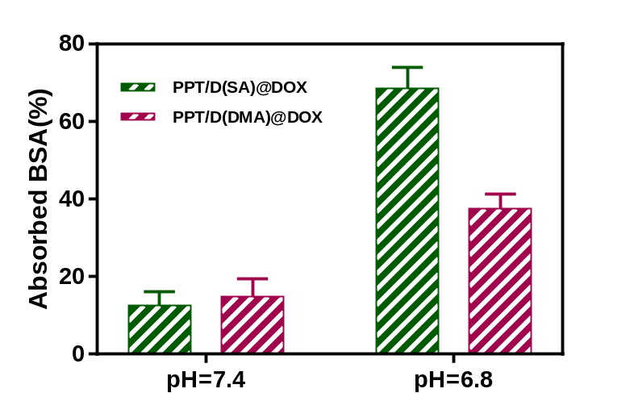
Fig.S4 BSA adsorption on the PPT/D(SA)@DOX and PPT/D(DMA)@DOX micelles pretreated with pH 6.8 and 7.4.
Fig.S5 Fluorescence images of A549 cells incubated with PPT/D(SA)@DOX and PPT/D(DMA)@DOX with the same concentration of 2.0 μg/mL for 2 h and 4 h at pH 7.4. The scale bar is 100 μm. Blue: DAPI; red: DOX.

